Practical No. 2
Aim: Installation and configuration of virtualization using KVM.

Step 1: Download the Ubuntu ISO
- Visit the Ubuntu Downloads page: https://ubuntu.com/download/desktop.
- Select the latest version of Ubuntu (e.g., Ubuntu 22.04 LTS).
- Download the ISO file (e.g., ubuntu-22.04-desktop-amd64.iso).
Step 2: Create a New Virtual Machine in VMware Workstation Pro
- Open VMware Workstation Pro 17.
- From the home screen, click on Create a New Virtual Machine.
- Select Typical (recommended) and click Next.
- Choose Installer disc image file (iso) and browse to the downloaded Ubuntu ISO.
- Choose the VM name (e.g., "Ubuntu-KVM") and select a location for the virtual machine.
- Set the disk size (e.g., 20 GB or higher) and choose Store virtual disk as a single file.
- Finish the wizard by clicking Finish.
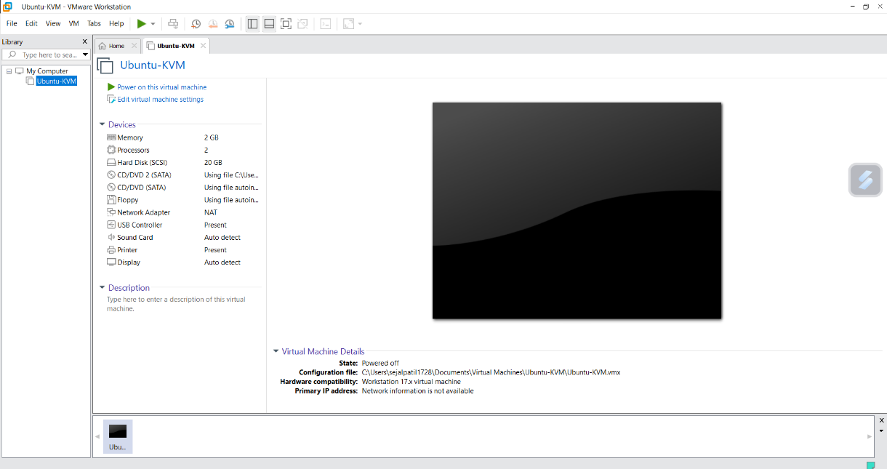
Step 3: Power On the Virtual Machine and Install Ubuntu
- Once the virtual machine is created, select it in VMware and click Power on.
- The Ubuntu installation will begin.
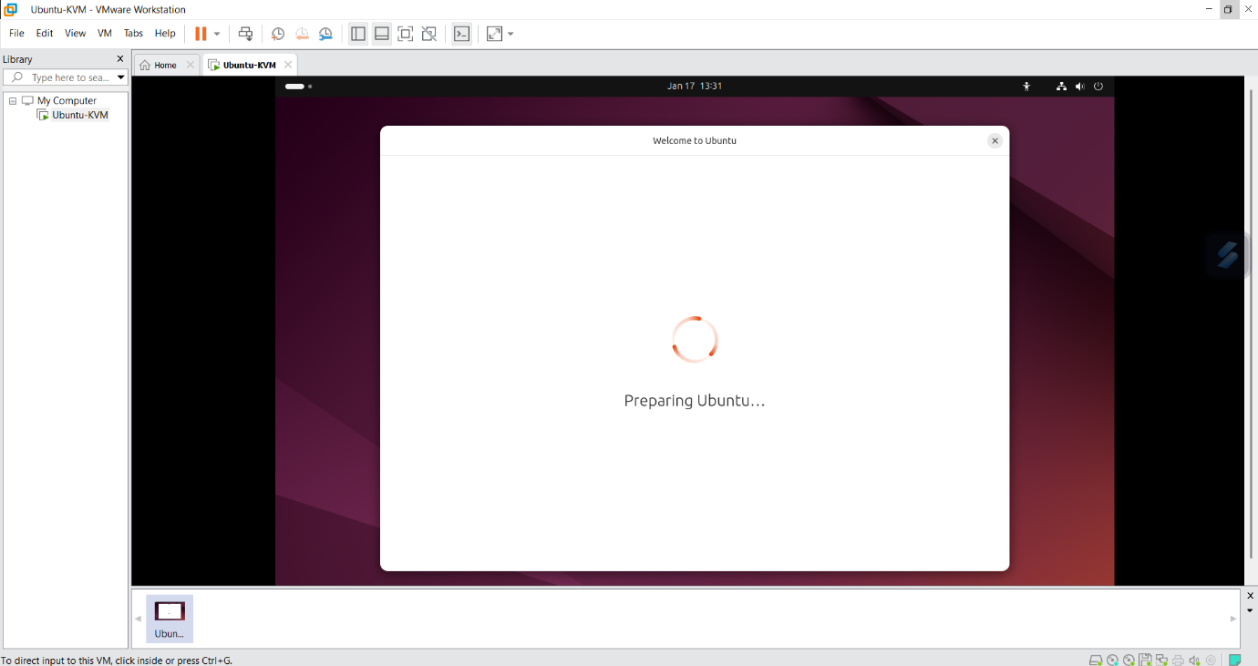
- Follow the on-screen instructions to complete the Ubuntu installation (Language, Time zone, User setup, etc.).
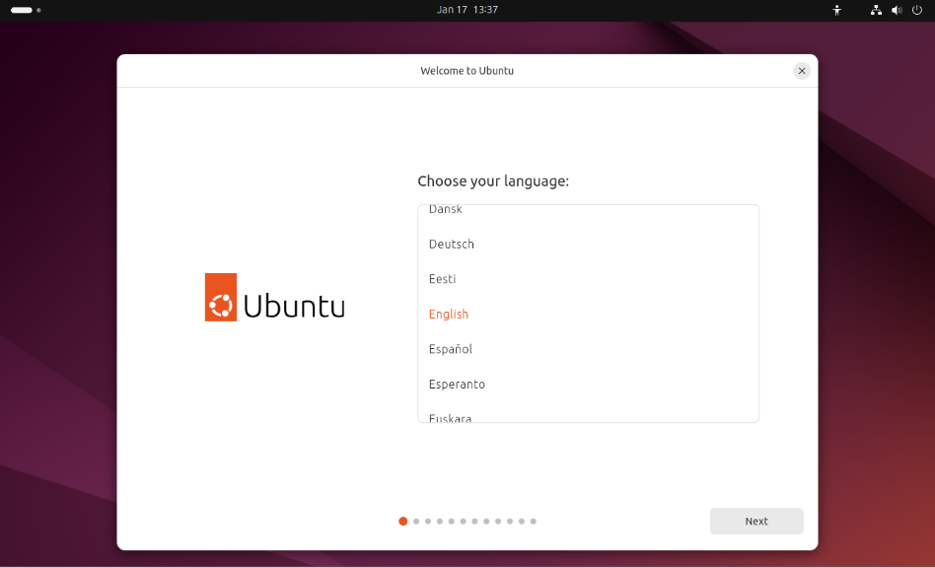
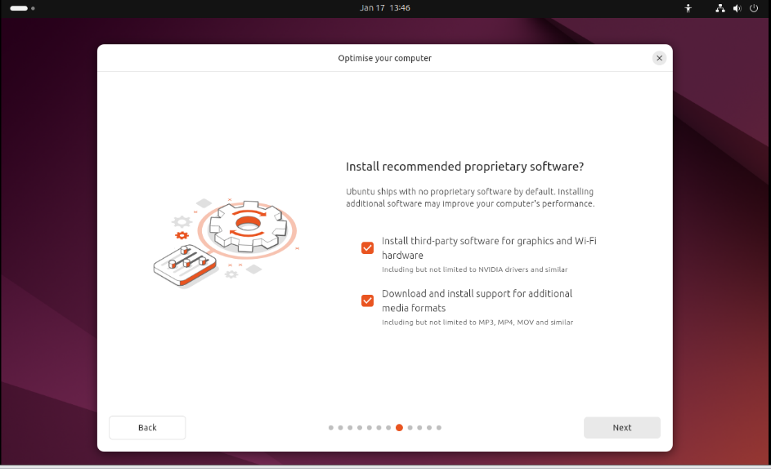
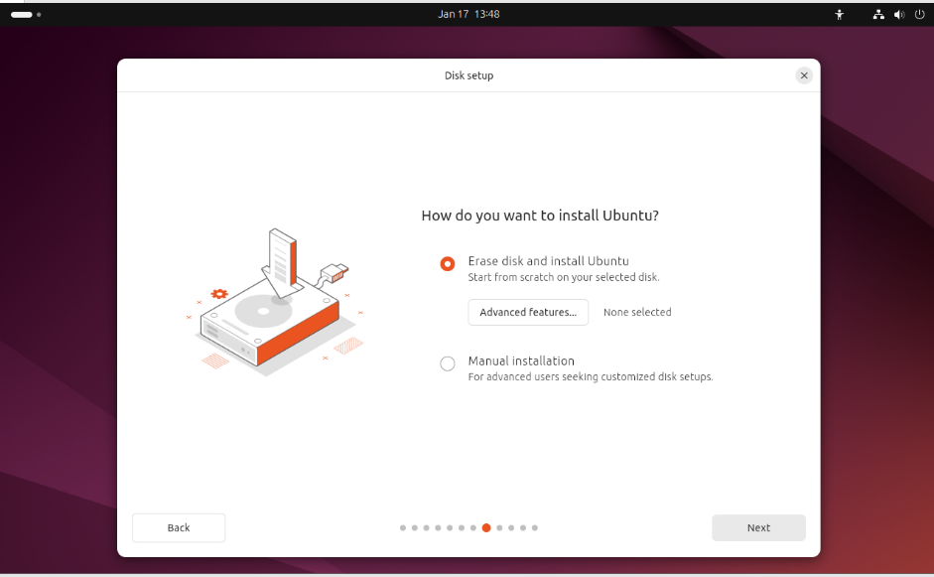
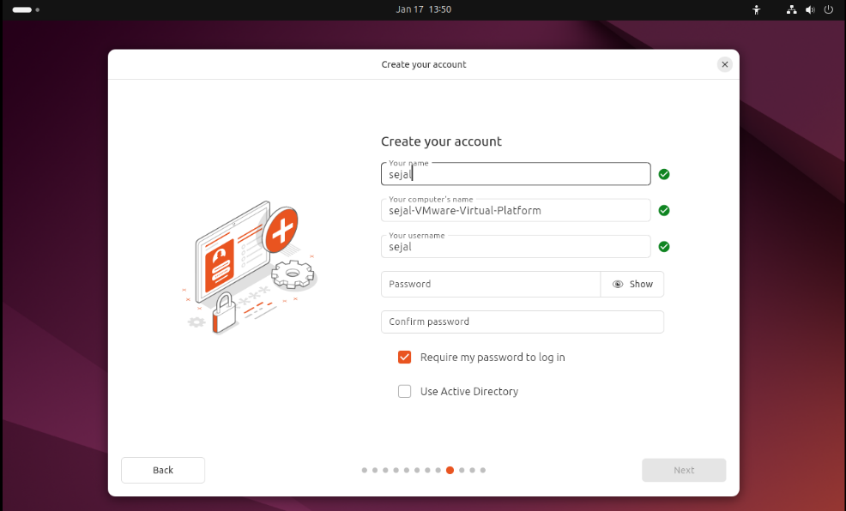
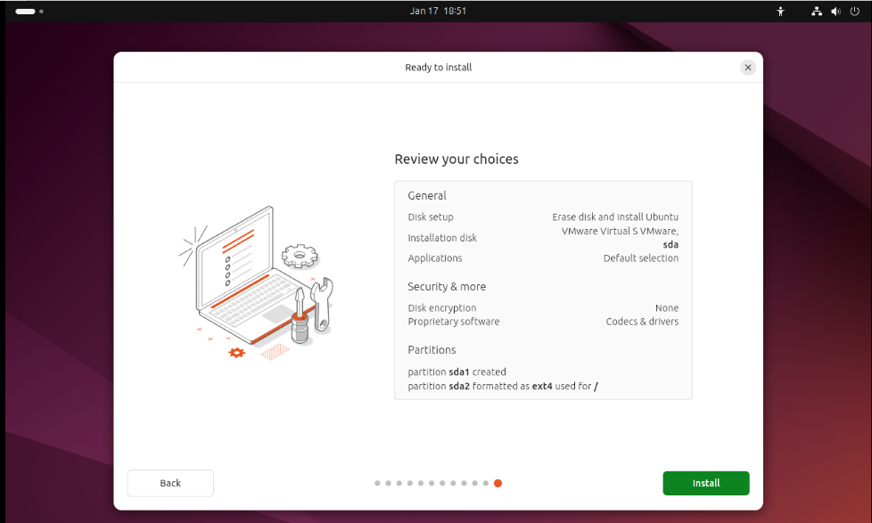
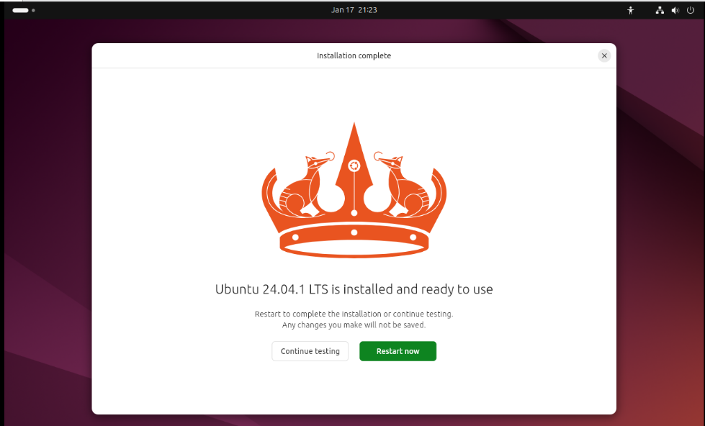
- When the installation is complete, reboot the system.
Step 4: KVM Related Packages in Ubuntu
- Once Ubuntu is installed, log in to the system.

- Open a Terminal in Ubuntu and execute the following commands to check if your system supports virtualization:
sudo grep -c "svm\|vmx" /proc/cpuinfo
  - svm: AMD processors.
  - vmx: Intel processors.
If the output is greater than 0, your CPU supports virtualization.
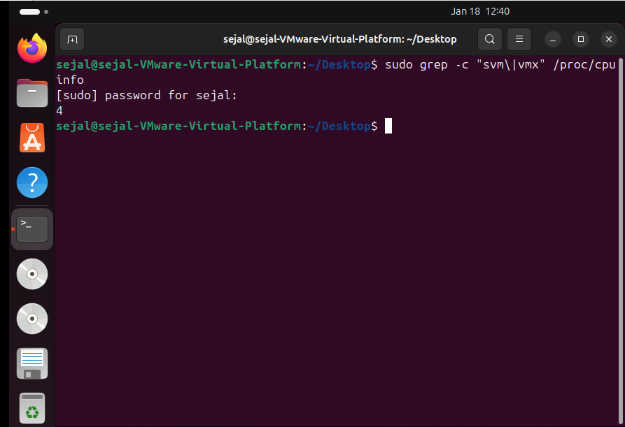
- Install KVM and related packages by running the following commands:
- sudo apt update
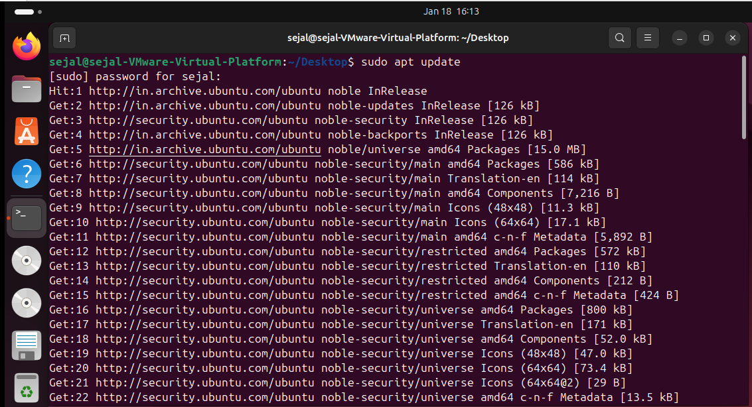

- sudo apt upgrade
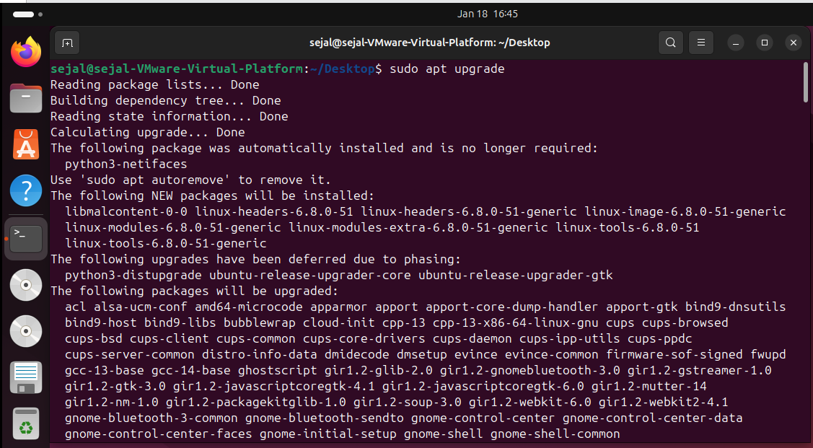
Step 4: Verify if KVM virtualization is enabled
  - sudo apt install cpu-checker
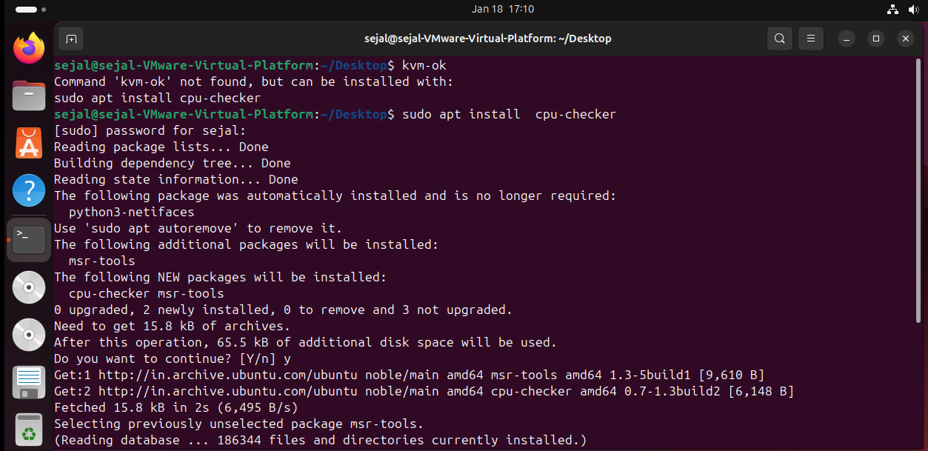
  - kvm-ok
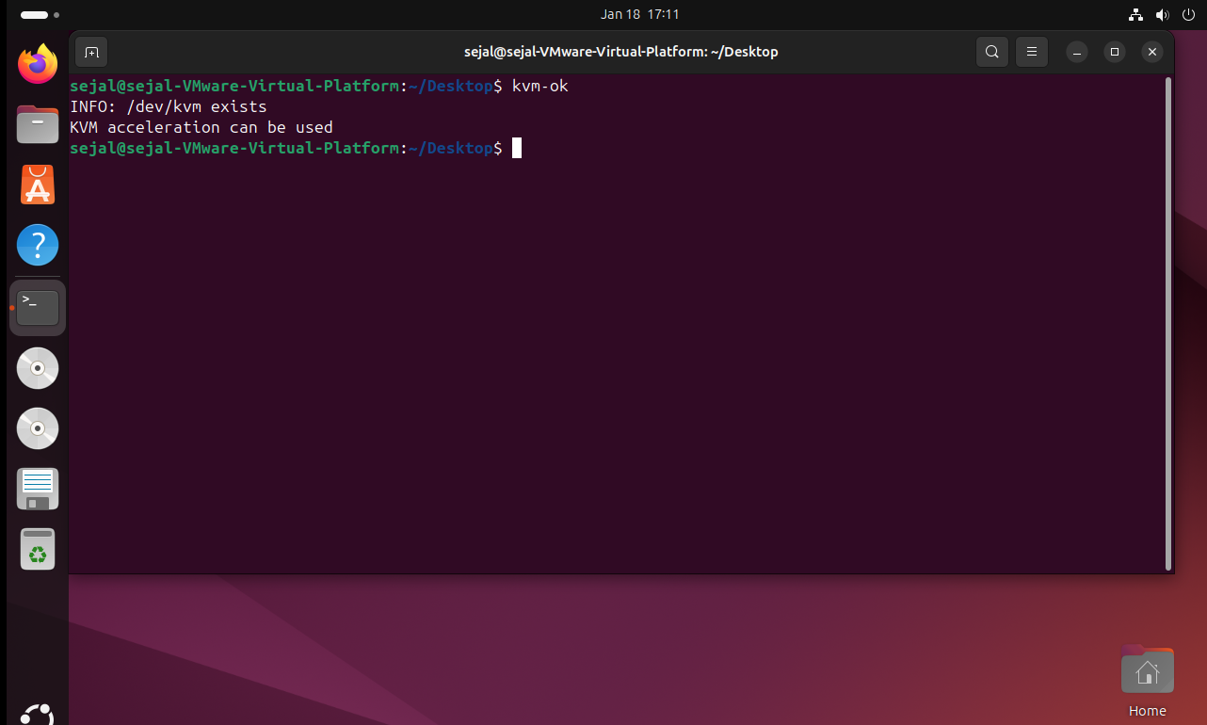
Step 5: Install KVM
  - sudo apt install qemu-kvm virt-manager libvirt-daemon-system virtinst libvirt-clients bridge-utils
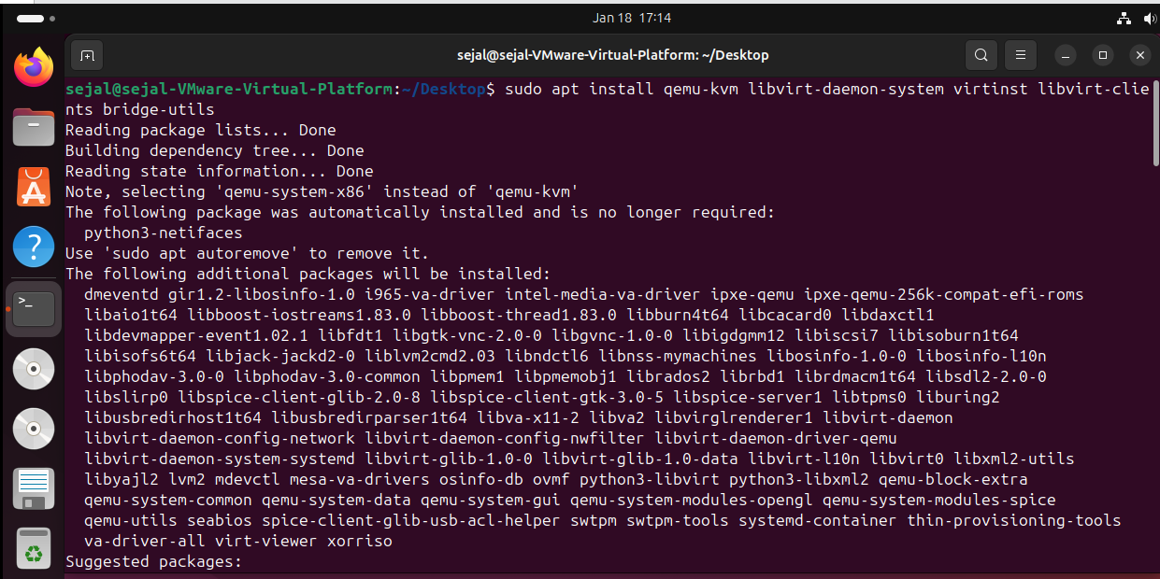
Step 6 : Enable the virtualization daemon
- Sudo systemctl enable –now libvirtd
- subo systemctl start libvirtd
- subo systemctl status libvirtd
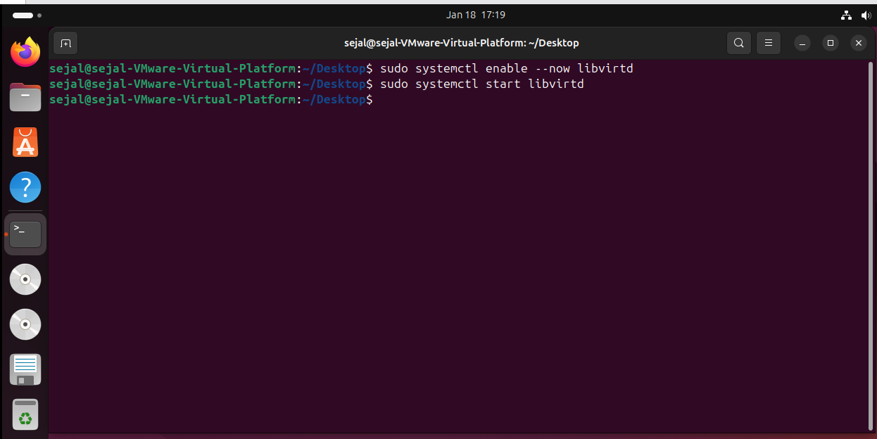
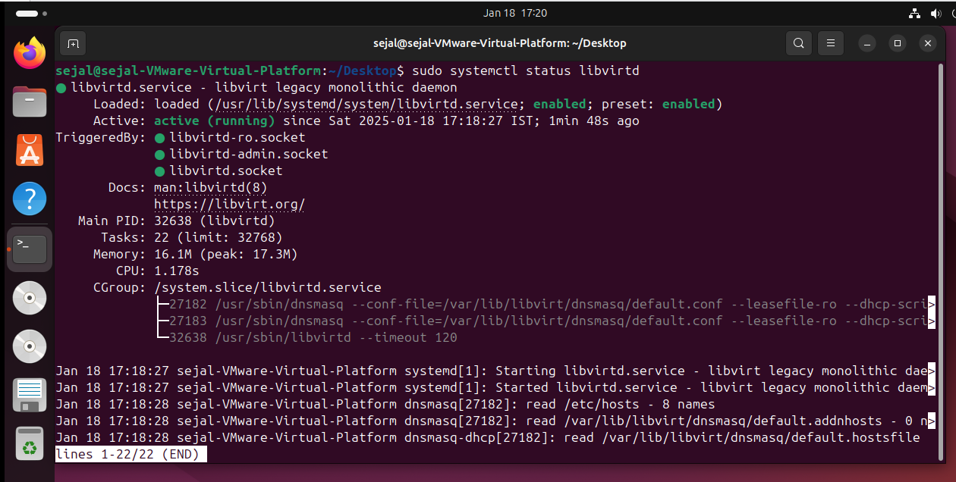
Step 7: Add your user to the KVM and libvirt group and kvm group
1. sudo adduser sejal libvirt
2. sudo adduser sejal kvm
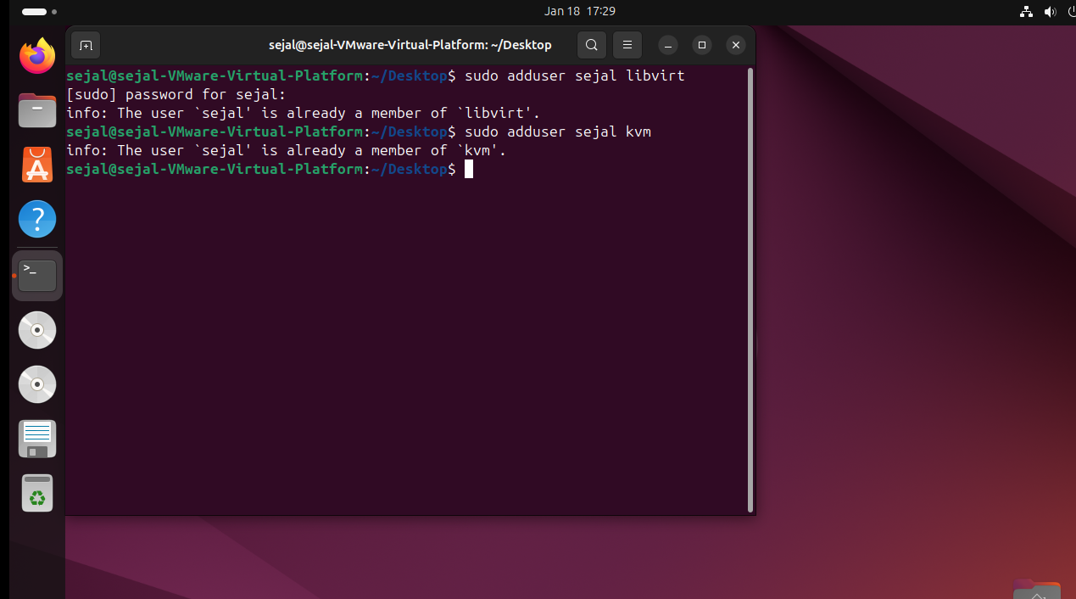
Step 8 : Install the virt-manager
- sudo apt install virt-manager
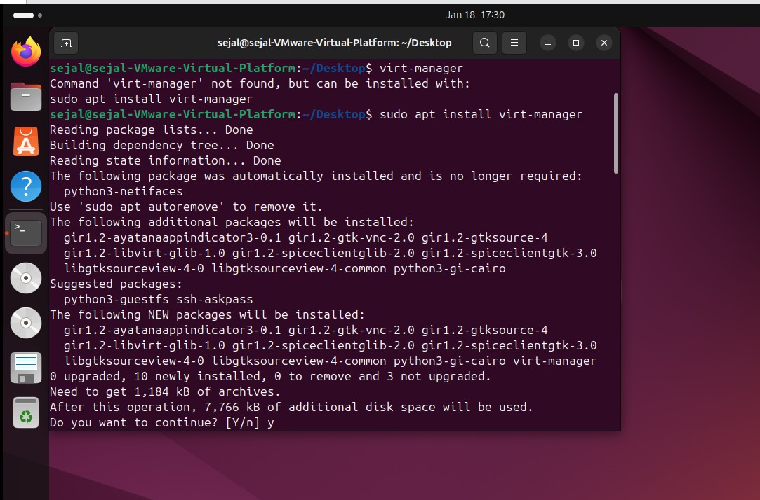
Step 9 : Search the virtual machine or run “virt-manager” command.
